ISSN 0494-3244
Тутун/Tobacco, Vol. 71, N⁰ 1-6, 3-11, 2025 UDK: 633.71-153.037:631.67(497.785)”2022/2023”
Оriginal Scientific Paper

ALTERNATIVE IRRIGATION METHODS IN TOBACCO SEEDLING PRODUCTION
Kristina Hristovska¹*, Biljana Jordanoska Shishkoska¹, Vesna Krsteska¹, Marjana Glusheska¹
University “St. Kliment Ohridski” - Bitola, Scientific Tobacco Institute- Prilep,
Kicevska bb, 7500 Prilep, Republic of North Macedonia
kristina.hristovska@uklo.edu.mk

ABSTRACT
Irrigation is a fundamental agronomic practice in tobacco seedling production; however, seedlings are still predominantly grown using conventional, labor-intensive methods that result in significant water loss and increased susceptibility to diseases. The aim of this study was to evaluate the effects of different irrigation methods on the total number and quality of healthy tobacco seedlings. Three irrigation treatments were compared: manual watering with a perforated can (control), sprinkler irrigation, and overhead micro-sprinkling (micro-rain). Micro-sprinkling significantly improved seedling performance, resulting in the highest plant density (2990 plants m⁻²) and the greatest number of seedlings suitable for transplanting (2122 plants m⁻²), compared to the control (2660 plants m⁻², 1862 suitable). Seedlings under micro-sprinkling reached transplant readiness 5–10 days earlier, achieved greater height, and developed a more robust root system. These results were consistently confirmed over two consecutive years, highlighting micro-sprinkling as a water-efficient and practically applicable irrigation method.
Keywords: irrigation, tobacco seedlings, micro-sprinkling, watering can, sprinkler

АЛТЕРНАТИВНИ НАЧИНИ НА НАВОДНУВАЊЕ ПРИ ПРОИЗВОДСТВОТО НА ТУТУНСКИ РАСАД
Една од основните агротехнички мерки при производството на тутунски расад е наводнувањето. Сè уште најчесто расадот се произведува во ладно усовршени леи со традиционални методи на наводнување, кои се трудоинтензивни, со големи загуби на вода и висок ризик од појава на болести. Целта на истражувањето беше да се испита влијанието на различните начини на наводнување врз вкупниот број и квалитетот на здрав тутунски расад. Три варијанти беа споредени: рачно полевање со канта со решетка (контрола), наводнување со распрскувачи и оросување преку микродождење. Микродождењето значително го подобри растот на расадот, со најголема густина на растенија (2990 растенија/m²) и број на погодни растенија (2122/m²), во однос на контролата (2660 растенија/m², 1862 погодни). Расадот достигна зрелост за 5–10 дена порано, имаше поголема висина и поцврст коренов систем. Резултатите беа повторливо потврдени во двете години на истражувањето, што укажува на водо-ефикасен и применлив начин на наводнување.

Клучни зборови: наводнување, тутунски расад, микродождење, канта, распрскувач
INTRODUCTION
The Prilep region is recognized for producing high-quality fine-leaf aromatic tobacco of the Prilep type, where water management plays a central role in ensuring the production of healthy, uniform, and timely-grown tobacco seedlings. Tobacco seedlings are the foundation of the final crop, as their health and vigor strongly influence both quantitative and qualitative traits of harvested leaves (Bozukov, 2002; Pelivanoska, 2009). High-quality seedlings are uniform in size, protected against diseases, pests, and weeds, adequately hardened, and ready for early transplanting (Donev & Karadzov, 1958). According to Balliu et al. (2017), seedlings are considered high-quality if they are disease- and pest-free, adapt easily to new conditions after transplanting, possess a well-developed root system, and have leaves without visible damage, such as chlorosis or necrosis. Mickovski (2004) further emphasizes that seedlings intended for transplanting should be fully healthy, hardened, uniform, light green in color, 12–15 cm in length (from the root tip to the top of developed leaves), with 5–6 fully developed leaves and a robust root system.
Seedling production is a complex process, strongly influenced by local climatic conditions, agronomic practices, and phytosanitary measures (Pelivanoska et al., 2006). Irrigation is a key factor affecting soil moisture, nutrient availability, and overall seedling growth (Pelivanoska, 2009; Kukutanov, 2015). Traditional methods, including manual watering with cans or hoses equipped with sprinklers, remain widespread but are labor-intensive and less water-efficient, with disease incidence often higher. Sprinkler irrigation efficiency in conventional systems is around 75%, whereas micro-irrigation methods can achieve up to 90% efficiency (Chukaliev et al., 2003).
Recent studies have demonstrated the advantages of micro-sprinkler and drip irrigation for improving water-use efficiency, seedling uniformity, and crop establishment (Guang et al., 2019; Rao et al., 2011; Yang et al., 2022; Kaya et al., 2015). Micro-irrigation provides more uniform water distribution, reduces water loss, accelerates vegetative development, and improves root system establishment. These methods have also been shown to improve resource efficiency in seedlings beyond tobacco, making them relevant for broader horticultural and field crop production (Kaya et al., 2015). Despite these advantages, adoption is often limited by higher investment costs and operational requirements (Gichev, 1997; Mickovski, 2004).
However, few studies have quantified the effects of different irrigation methods on early-stage tobacco seedlings under field conditions, leaving a knowledge gap for optimizing local production practices. Understanding the comparative benefits of micro-sprinkling versus traditional irrigation is essential for increasing seedling uniformity, reducing labor, and improving water use efficiency in commercial tobacco nurseries. This study aims to address this gap by evaluating the effects of three irrigation methods on seedling density, growth parameters, and root development.

MATERIAL AND METHODS

Two-year experiments (2022–2023) were conducted using the tobacco cultivar Prilep P-66 at the experimental field of the Tobacco Research Institute–Prilep, on a plot suitable for seedling production. Seeds were sown at a rate of 4.5 g m⁻² in line with recommended rates for this cultivar (Korubin-Aleksoska, 2004). The experiment included three irrigation treatments; each replicated four times. The first treatment served as a control and was irrigated manually using a perforated watering can. The second treatment was irrigated using sprinklers, while the third treatment employed overhead micro-sprinkling (micro-rain) with micro-sprinklers (Figure 1).
For the micro-sprinkling treatment, sprinklers with a discharge rate of 60 L h⁻¹ were installed at 80 cm spacing, with a total of five micro-sprinklers per replicate. Particular attention was paid to ensure uniform water distribution across the entire seedbed. The hoses above the seedbeds were mounted on metal supports at approximately 60 cm height. Each micro-sprinkler provided 360° coverage with a 20% overlap between sprinklers. Seedlings in the control were irrigated with a 12 L perforated watering can. Irrigation for all treatments was applied once per day, with the amount of water adjusted according to the seedling growth stage and environmental conditions.

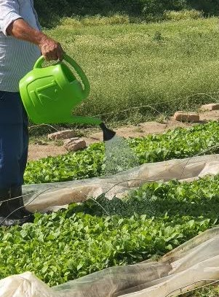 | 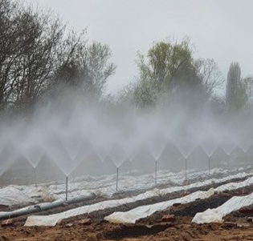 | 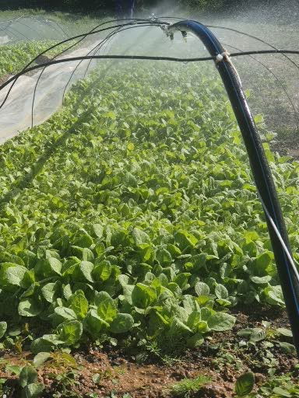
can | Sprinkles | microsprinkler
Figure 1. Different irrigation methods
Apart from irrigation, all other agronomic practices and plant protection measures were applied uniformly across treatments. Seedlings from each treatment were randomly sampled to determine total emergence per m² and the number of seedlings suitable for transplanting. Two samplings were conducted per treatment. During the two-year study, the effects of irrigation method on seedling developmental stages, total and transplantable plant numbers, root system length, and plant height were monitored. Measurements included: total seedling density per m², number of seedlings suitable for transplanting, seedling height, and root length (average of 30 seedlings per plot). Two harvests per year were conducted at transplant readiness. Data were expressed as mean ± standard deviation and analyzed using one-way ANOVA, with treatment differences tested by Tukey’s HSD at p < 0.05.
RESULTS AND DISCUSSION
Seedling development varied significantly among irrigation treatments. Micro-sprinkling accelerated the growth period from sowing to transplant readiness to 46 days, compared with 51 days for sprinkler irrigation and 56 days for manual watering (Figure 2).
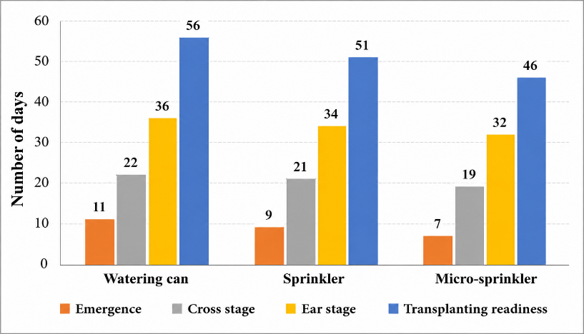
Figure 2. Developmental phases and length of the vegetation period of the tobacco seedlings

The results of this two-year study demonstrate that irrigation method significantly affects tobacco seedling performance, including plant density, root development, and the number of transplantable seedlings. Micro-sprinkling irrigation consistently outperformed both traditional can watering and sprinkler irrigation across all measured parameters. Seedling density was highest under micro-sprinkling, with total and transplantable plants increased by 7.2 % and 7.9 %, respectively, compared with the control (Table 1). Sprinkler irrigation showed intermediate values but did not differ significantly from the control.
Table 1. Effect of irrigation method on tobacco seedling density (mean 2022–2023).
Treatment | Total plants (m²) | % of control | Transplantable plants (m²) | % of control
Can (control) | 2660 a | 100.0 | 1862 a | 100.0
Sprinkler | 2790 ab | 104.9 | 1966 ab | 105.6
Micro-sprinkling | 2990 b | 107.2 | 2122 b | 107.9
ANOVA (F) | 4.742 | — | 12.478 | —
ANOVA (p) | 0.0392* | — | 0.0025** | —

Notes: Values represent means for the 2022–2023 growing seasons. Percent values are expressed relative to the control treatment (can irrigation = 100%). One-way ANOVA was used to test treatment effects. Means followed by different letters within a column differ significantly according to Tukey’s HSD test at p ≤ 0.05. Significance levels: p ≤ 0.05 (*), p ≤ 0.01 (**); ns = not significant.

Analysis of variance confirmed significant treatment effects for total plant density (F = 4.742, p = 0.0392) and transplantable plants (F = 12.478, p = 0.0025). Tukey’s HSD test indicated that micro-sprinkling was significantly superior to both can and sprinkler irrigation, while differences between sprinkler irrigation and the control were not significant.
The superior performance of micro-sprinkling aligns with broader agronomic evidence that precision low-intensity irrigation systems improve water distribution uniformity and enhance vegetative growth. Micro-sprinklers deliver water gently and uniformly across the root zone, reducing spatial variability in soil moisture and creating favorable microclimatic conditions for photosynthesis, root development, and water use efficiency (Zhou et al., 2021; Guang et al., 2019). Improved water delivery supports nutrient uptake, root elongation, and transplant readiness, consistent with previous studies on tobacco and other crops (Rao et al., 2011; Yang et al., 2022; Fereres & Soriano, 2007).
In contrast, standard sprinkler irrigation often provides less uniform water coverage, resulting in higher surface evaporation and lower water availability in the root zone. While sprinklers may increase growth relative to manual watering, their efficiency is generally lower than micro-sprinkling under nursery conditions where uniform seedling establishment is critical.
Overall, micro-sprinkling irrigation enhances tobacco seedling production by delivering water according to plant demand, reducing soil moisture variability, and producing more uniform and robust seedlings. Adoption of micro-sprinkler systems in tobacco nurseries can improve seedling quality, increase transplant success, and optimize water use efficiency, offering practical advantages for commercial seedling production.

Root system development
According to Table 2, root system length of transplantable seedlings increased significantly under both sprinkler (+14.1%) and micro-sprinkling (+17.0%) irrigation compared to the control. Observations during the study indicated that seedlings under micro-sprinkling irrigation developed the most robust root systems, with more extensive adventitious root growth (Figure 2). These results are consistent with the principle that low-intensity irrigation systems enhance root growth by providing uniform soil moisture and improved aeration (Fereres & Soriano, 2007; Wang et al., 2020).
Table 2. Effect of irrigation method on tobacco seedling root length (cm, mean of 30 plants)
Treatment | 2022 | 2023 | Mean | % of control
Can (control) | 4.30 | 4.07 | 4.19 | 100.0
Sprinkler | 4.84 | 4.71 | 4.78 | 114.1
Micro-sprinkling | 5.75 | 5.42 | 5.59 | 117.0

Figure 2. Influence of irrigation method on the development of the root system of tobacco seedlings

The effect of irrigation on root development is illustrated in Figure 2, showing that micro-sprinkling produced a more developed root system compared to the can) and sprinkler treatments.

Seedling height
Table 3 shows that the height of transplantable tobacco seedlings was greatest under micro-sprinkling (18.41 cm, +1.7% compared to control 17.95 cm). Sprinkler irrigation produced a smaller, nearly negligible increase (18.09 cm, +0.8%). These findings suggest that irrigation method positively affects seedling height suitable for mechanical transplanting, though above-ground growth is less sensitive to irrigation than root development.

Table 3. Effect of irrigation method on tobacco seedling height (cm, mean of 30 plants).
Treatment | 2022 | 2023 | Mean | % of control
Can (control) | 18.02 | 17.88 | 17.95 | 100.0
Sprinkler | 18.86 | 17.32 | 18.09 | 100.8
Micro-sprinkling | 19.03 | 17.78 | 18.41 | 101.7

Practical implications and limitations
In our country, tobacco seedlings are still irrigated traditionally with buckets or, in industrial production, via low-pressure sprinkler systems. Sprinkler irrigation delivers water in fine droplets mimicking natural rainfall (Gichev, 1997; Mickoski, 2004), while micro-sprinkling provides a more uniform water distribution through a network of plastic pipes and micro-sprinklers. The study confirms that micro-sprinkling or sprinkler irrigation can successfully replace traditional methods, resulting in earlier transplant readiness (46 days vs 51–56 days for other methods), higher transplantable plant numbers per m², and better root and shoot quality.
Some practical limitations were observed, including minor post-irrigation droplet accumulation causing uneven germination under specific sprinklers and higher initial investment costs for micro-sprinkling infrastructure. These constraints are common in smallholder adoption of advanced irrigation systems (Bozukov, 2002). Future studies should consider cost-benefit analyses and long-term field trials to optimize system performance and economic feasibility.
Overall, micro-sprinkling irrigation provides a reliable approach to producing high-quality, uniform, and early-ready tobacco seedlings, outperforming traditional methods in both quantitative and qualitative traits. These findings contribute to improving local tobacco seedling production practices while optimizing water use efficiency.

CONCLUSIONS
This study investigated the effect of different irrigation methods on the growth and quality of tobacco seedlings, aiming to identify approaches that improve seedling uniformity and readiness for transplanting. Our results demonstrate that irrigation method plays a crucial role in determining seedling performance. Micro-sprinkling irrigation consistently produced the most vigorous seedlings, with well-developed root systems and suitable heights for mechanical transplanting, indicating its potential to enhance transplant success and overall nursery efficiency.
Sprinkler irrigation also provided improvements over traditional can watering, but to a lesser extent, highlighting that even modest enhancements in water distribution can positively affect seedling development. The findings suggest that adopting low-intensity, uniform irrigation systems can contribute to more resilient and uniform seedlings, reduce nursery time, and support higher-quality planting material.
These results have practical implications for tobacco production, offering an alternative to traditional irrigation methods that can improve seedling quality and operational efficiency. Future research should focus on optimizing micro-sprinkling systems to address practical challenges, such as uneven residual water distribution and cost considerations, and to evaluate their long-term impact on field establishment and crop performance.

REFERENCES

- Balliu, A., Maršiü, N. K., & Grudaca, N. (2017). Good agricultural practices for greenhouse vegetable production in the South East European countries: Principles for sustainable intensification of smallholder farms. Rome: Food and Agriculture Organization of the United Nations.
- Bozukov, H. (2002). Alternative solutions for tobacco seedling production. Tobacco, 52(1–2), 19–24. Institute of Tobacco, Prilep, North Macedonia.
- Chukaliev, O., Iljovski, I., Sekuloska, T., & Tanaskovic, V. (2003). Fertigation for improved plant production and environmental protection in the Republic of Macedonia: Handbook. Skopje: Faculty of Agriculture & GTZ.
- Donev, N., & Karadzov, I. (1958). On some basic issues in tobacco seedling production. Sofia: Zemizdat.
- Fereres, E., & Soriano, M. A. (2007). Deficit irrigation for reducing agricultural water use. Journal of Experimental Botany, 58(2), 147–159. https://doi.org/10.1093/jxb/erl165
- Guang, H., Li, X., & Wang, Y. (2019). Micro-sprinkler irrigation improves seedling uniformity and water efficiency in tobacco. Agricultural Water Management, 213, 117–125. https://doi.org/10.1016/j.agwat.2018.10.028
- Gichev, A. (1997). Land reclamation with erosion protection. Skopje: AD “Goce Delchev”.
- Karkanis, A., et al. (2018). Seedling quality and transplant establishment in vegetable crops. Agronomy, 8, 226. https://doi.org/10.3390/agronomy8120226
- Kaya, C., Higgs, D., et al. (2015). Effects of micro-irrigation on seedling growth and water use efficiency. Journal of Plant Nutrition and Soil Science, 178(6), 853–863. https://doi.org/10.1002/jpln.201400445
- Korubin-Aleksoska, A. (2004). Tobacco varieties from the Institute of Tobacco – Prilep. Bitola: University “St. Kliment Ohridski” & Public Institution Institute of Tobacco – Prilep.
- Kukutanov, R. Đ. (2015). Reclamation and irrigation [Electronic resource]. Štip: University “Goce Delchev”, Faculty of Agriculture.
- Mickovski, J. (2004). Tobacco in the Republic of Macedonia. Prilep: Society for Science and Art.
- Pelivanoska, V. (2009). Quantitative and qualitative characteristics of the small-leaf Oriental tobacco variety P-66. Tobacco, 59(9–10), 213–219. Institute of Tobacco – Prilep, North Macedonia.
- Pelivanoska, V., Trajkoski, J., & Naumoska, M. (2006). Some new technologies for tobacco seedling production. Tobacco, 56(1–2), 11–16. Institute of Tobacco – Prilep, North Macedonia.
- Rao, M., Raju, A., & Kumar, P. (2011). Drip and micro-sprinkler irrigation effects on seedling growth and resource efficiency. Irrigation Science, 29, 125–134. https://doi.org/10.1007/s00271-010-0245-8
- Taiz, L., Zeiger, E., Møller, I. M., & Murphy, A. (2015). Plant physiology and development (6th ed.). Sunderland, USA: Sinauer Associates.
- Uzunoski, M. (1985). Tobacco production. Skopje: Stopanski Vesnik.
- Yang, W., Zhang, J., & Li, F. (2022). Optimization of micro-irrigation for improved crop establishment and uniformity. Agricultural Water Management, 261, 107245. https://doi.org/10.1016/j.agwat.2022.107245
- Zhou, H., et al. (2021). Micro-sprinkler irrigation enhances seedling growth and water use efficiency. Agricultural Water Management, 245, 106619. https://doi.org/10.1016/j.agwat.2020.106619

